AMABEL MOSELEY

BRITISH CHAMPION

Much has been written about the tiny Mary Mills Houlding who came back to the UK from Australia, settled in Newport and won the British Ladies’ Championship several times. Well, we have our very own home-grown British Ladies champion in the person of Amabel Solas nee Moseley nee Jeffreys..

She was born on 8th March 1855 at Llangennech, daughter of John Gwyn Jeffreys, a barrister and eminent conchologist. The family moved to Hertfordshire where they lived in The Priory at Ware. In February 1878 she married Henry Nottidge Moseley, Registrar of London University and a renown marine biologist. She was widowed in 1891 and her second marriage in 1914 was to William Johnson Sollas, Professor of Geology at Oxford. Her only son, a brilliant physicist, was killed at Gallipoli in 1915 at the age of 27.

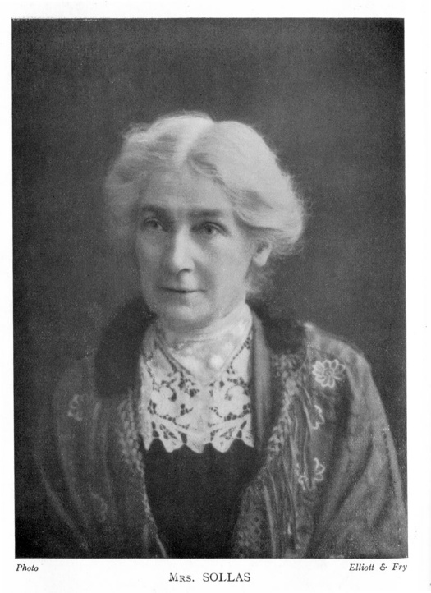

In 1911 at Glasgow Amabel Moseley as she was, came second to Mrs. Houlding. Her BCM obituary stated that she was a regular competitor in mixed events.

As Mrs Moseley she won the British Ladies Championship in 1913 at Cheltenham after a tie with Mrs. Stevenson and Miss Hutchinson-Sterling. She had scored 7 ½ out of 11 in the main event, losing three games but drawing only one.

Mrs Sollas died in May 1928 as the result of a road accident, shortly after leaving the Oxford City Chess Club.

SOURCES
Britbase
BCM June 1928

